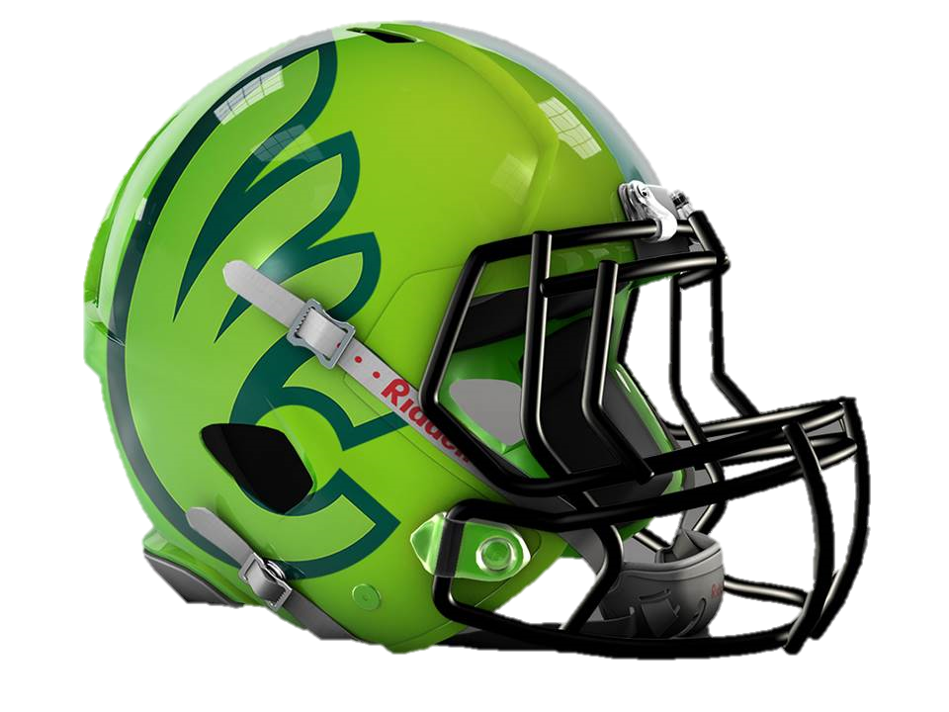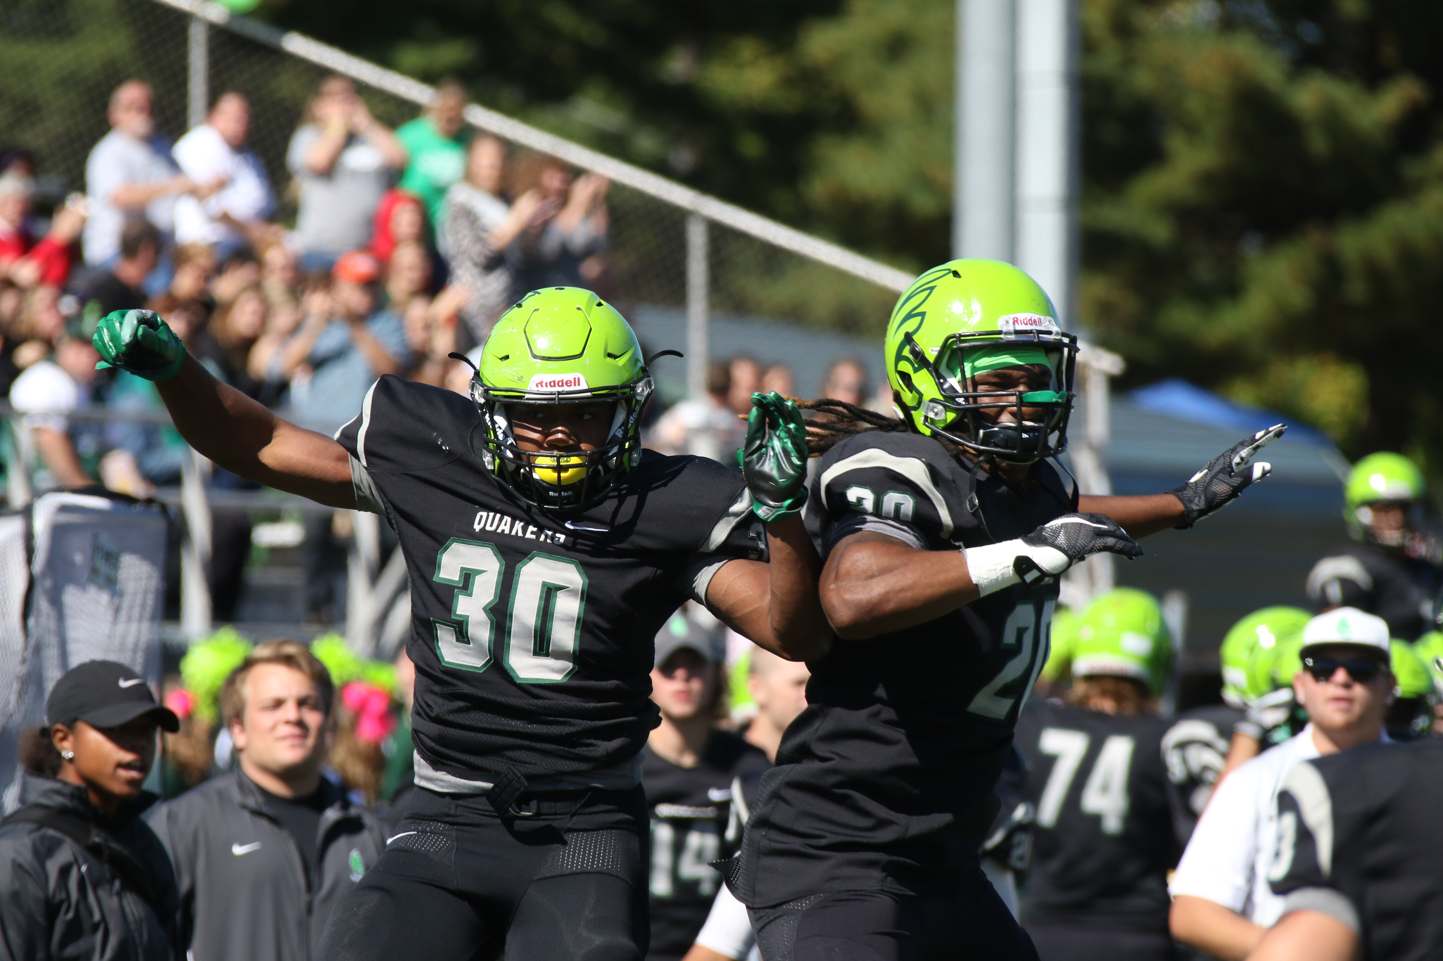

**Typical Day**

9:00 Opening Remarks- Stretch & Flex

9:15 Instruction of Offensive Skills

9:45 Water Break

9:55 Instruction of Defensive Skills

10:25 Water Break

10:35 Instruction of Special Teams Skills

(Kicking, Punting, Long snapping)

10:55 Water Break

11:05 Competition Period

11:20 Water Break

11:30 Speed Ball Game #1

11:45 Speed Ball Game #2

12:00 Dismissal

* **Speed Ball** is a fast-paced, non-contact game where all participants are able to catch the ball and run. The campers will be divided into two divisions based on age, and play a tournament throughout camp. All players play skill positions.

Youth Camp

June 19th- 22nd

**AUTHORIZATION**

**I hereby and herein authorize the Directors of the Wilmington College Football Youth Camp, or any agents working on their behave, to act in my stead for the purpose of acquiring emergency medical attention for my son or daughter or ward. I impose upon the assumptors of this duty the responsibility to act with reasonable care and caution and release and waive all liability for any injuries and illness incurred while at the camp in the event same is performed pursuant to such standard. By my signature hereunder, I warrant that my son/daughter or ward is in good physical condition, has no undisclosed medical problems, illness or disabilities, and is capable of full and active participation in the football camp. I also represent that my son/daughter or ward has received a physical within the last year and is medically competent to participate in the activities at camp.**

**Signature of Parent or Guardian __________________________________________________________________ Date_____________________**

**Signature of Camper_________________________________________________________________________________ Date_____________________**

**COSTS**

The cost for the 2017 Wilmington College Football Youth Camp is $70. Please include payment with the registration form by June 10th.

Checks payable to Wilmington College Football and mail to: Wilmington College Football

1870 Quaker Way

Wilmington, OH 45177

**STAFF**

The Wilmington College Football Youth Camp will be staffed by the new Wilmington College football staff and players. You can expect your camp experience to be filled with energy, effort and enthusiasm throughout the week. The Wilmington Coaches will ensure the camp is fun and informative.

**The Camp Staff will include**:

**Bryan Moore**- Head Football Coach

**Corey Fillipovich**- Defensive Coordinator/LB

**Brad Watkins**- Defensive Line/ Special Teams

**Matt Byrne**- Run Game Coordinator/O-Line

**Jaylin Kennedy**- Defensive Backs

**Hayden Thomas**- H-Backs/ O-Line

Eric Fox – Running Backs

**Name_______________________________________________________________________________**

**Address____________________________________________________________________________**

**City_____________________ State_______________ Zip__________________**

**Parents____________________________________________________________________________**

**Emergency Contact__________________________________________ Phone Number____________________________________**

**Insurance Company_______________________________________________**

**Policy Number____________________________________________________________**

**T-Shirt Size YM YL AS AM AL AXL AXL AXXL E-mail Adress___________________**

**Campers Age_______________________ Campers Grade_____________ Campers School__________________**

**Campers Food Allergies______________________________**

ABOUT THE CAMP

The Wilmington College Football Camp is designed to serve campers ages 6 to 13 in all areas of football development. The purpose of our youth camp is to provide high quality football instruction to Wilmington and surrounding communities. The non-contact instruction by our experienced staff will improve the skill level and football IQ of our campers. The camp will instruct each day on offense, defense, special teams, age appropriate strength and conditioning, and flexibility and speed improvement. We will instruct the importance of academics and how crucial it will be for their success moving forward into high school and beyond. The new coaching staff and players from Wilmington will work directly with campers to ensure a safe, exciting, and fun-filled experience for all attendees.

Whether you are an experienced player, or a first time participant, our camp will improve your skills and give you a better understanding of the fundamentals, concepts, execution, and team work necessary to form a championship player and team. Each camper will receive a detailed evaluation, a camp t-shirt, and a camp certificate of completion. We look forward to working with your child in a family-friendly, positive, fun-filled environment.

Our camp will run from Monday to Thursday, June 19-22. The camp will begin at 9:00 AM and conclude at noon daily. Please arrive early on the first day to help with registration. Our staff will be on hand beginning at 8:00 AM for registration, and will be available for the monitoring of campers at 8:30 for the remainder of camp. Registration, drop-off, and pick up each day will be at the Wilmington College Football Stadium on the campus of Wilmington College.

Questions, please contact:

Jon Sandwisch

Camp Director

jon_sandwisch@wilmington.edu