TEACHING PHILOSOPHY

PURPOSE
Our objective is to provide each camper with a greater understanding of the fundamentals of both offensive and defensive basketball. This will be accomplished by enthusiastically emphasizing these fundamentals on an individual basis.

INSTRUCTIONAL EMPHASIS
Shooting-Special emphasis will be placed on shooting, including teaching proper mechanics.

Offensive Fundamentals-Individual and 3-on-3 concepts will be covered; ball-handling, passing, moving without the ball, individual moves, screening, using screens, posting, transition, footwork and offensive rebounding.

Terminology-Another special part of camp will be devoted to teaching important terms, rules, and concepts of the game.

LECTURES
Local college and high school coaches will speak about mental and moral aspects of the game. Local college players will form a roundtable to discuss, “What it takes to get where I am”, and “What it’s like to play college basketball.”

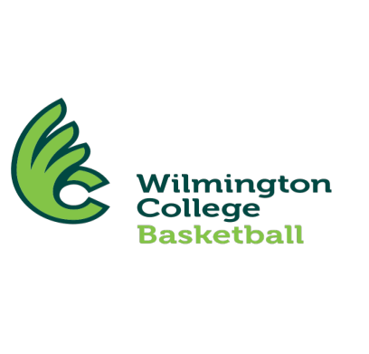

Our individual camp is scheduled from 9:00 am - 3:30 pm. Since this is only a day camp, housing is not provided but numerous campers commute and car pool from many of the surrounding areas. All Wilmington Men’s Basketball Camps are sponsored by Holiday Inn Express, which is conveniently located approximately one mile from campus. If needed, please inquire about arrangements to stay at Holiday Inn Express.


WILMINGTON HOLIDAY INN EXPRESS

937-382-5858 phone
937-382-0457 fax

WILMINGTON
COLLEGE
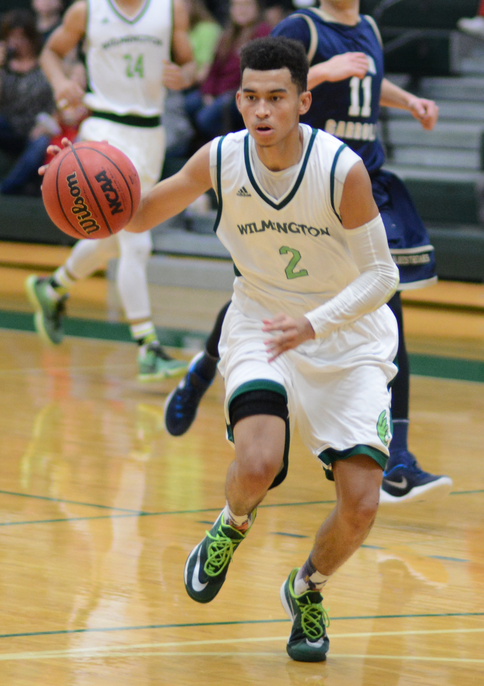

2017 BOYS
BASKETBALL CAMP
June 12-14
Grades 2 – 11

DATES & TIMES: 9:00 a.m. - 3:30 p.m.
June 12-14
Grades 2-11

CAPACITY: Enrollment will be limited, so please respond promptly.

DEADLINE: Mail back application, registration fee and waiver by June 1.

FACILITIES: Camp will be held daily at Hermann Court on the beautiful campus of Wilmington College. Hermann Court is one of the finest small-college basketball facilities in the Midwest.

CHECK IN TIME: 8-9 a.m.
Monday, June 12

WHAT TO BRING: Come each day dressed in shorts, socks, T-shirt, and gym shoes. Campers may want to bring a towel and extra gym clothes. Campers should either bring a small packed lunch, or can buy lunch at the concession stand. Pizza from Cassano’s of Wilmington will be available.

AWARDS: Awards will be given for various contests held throughout the week, as well as numerous other achievements.

COST: $100 ($50 non-refundable). Included in this price is a Wilmington Basketball Camp T-shirt. Cost for each additional family member is $75.

QUESTIONS: Call Head Coach K. C. Hunt in the Wilmington College Men’s Basketball office at 614-638-3312, or 937-481-2349. If no one is in, please leave a message.

TYPICAL DAILY SCHEDULE
9:00 Short talk and warm-up
9:15 Skills Workshop
- Shooting
- Defense
- Ball handling
- Footwork
- Rebounding
10:30 Contest/Competition
11:00 Team play (3-on-3)
12:00 Lunch
1:00 Guest speaker
1:20 Warm-up
1:30 Specialized Stations
- Shooting
- Individual moves
- Using screens
- Team defense
- Terminology
2:00 Contest/Competition
2:30 Team play (5-on-5)
3:30 End of daily session

CAMP DIRECTOR AND STAFF

K.C. Hunt, the Head Men’s Basketball Coach at Wilmington College, will direct the camp. The 2010 Great Lakes Region Coach of the Year, Hunt just concluded his eleventh season with the WC program and eighth as head coach. In 2010 and 2014 Hunt led WC to the OAC title and the NCAA Tournament.

Hunt will be aided by his assistant coaches, including Kerry Wilkinson former Wilmington starter, and Micah Mills. Hunt and Mills will oversee current WC players and area high school coaches.

In addition, camp speakers will include some of the outstanding college coaches and players in Ohio. As always, the strength of our camp will be the close personal attention our staff members give campers.

REGISTRATION AND WAIVER

Name:

Address:

City State Zip

Telephone:

Age: Grade next fall:
Adult
Shirt Size: S____ M____ L____ XL____

Emergency
Phone #:

Make check payable to: Wilmington College. Full payment must accompany the registration and waiver form. Send to:
K.C. Hunt
Wilmington Men’s Basketball Camp
Wilmington College
Pyle Box 1246
Wilmington, OH 45177

BASKETBALL RELEASE & WAIVER
I hereby authorize the staff of Wilmington College Basketball Camp to act for me according to their best judgment in any emergency requiring medical attention and I hereby waive and release Wilmington College, the camp directors and Wilmington College Basketball Camp from any and all liability for any physical impairments that would be affected by the above camper’s participation in the camp program, as outlined in the brochures.

Parent/Guardian Name:

Parent Signature: ________________________

